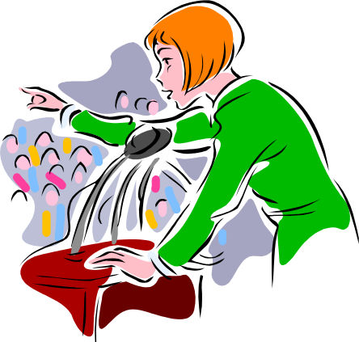

Presentation Software

By Jerry Belch
January 2007

Table of Contents
- PowerPoint Page 3
- HTML tags Page
- Wedding Planner Page 6
- Technical elements of Wedding Planner Page 7
- Mission statement Page Page 14
- Company Information Page Page 18
- Event Planning Page Page 23
- Web Page Department Page 27
- Fundraising Department Page 29
- Human Resources Page 30
- Sales and Marketing Department Page Page 30
- VP of Sales Page 35
- Product page Page 37
- Price page Page 38
- Promotion Page 42
- Place Page 44
- Grand Openings Page 47
- Trade Fairs Page 48
- Accounting Department Page Page 49
- Trial Balance Page 51
- Income Statement Page 54
- Balance Sheet Page 55
- Your Own page Page 56
- Java-Script Colors Page 57

Virtual Enterprise students need to make numerous presentations during the course of their program: grand openings, bank load presentations, advisory committees, school officials, business partners, business plans, year-end reports, etc. The digital standard for making these presentations is Microsoft’s Power Point program. It is a widely used program, so much so as many people refer to it as the only vehicle for presentations. Much like Scotch Tape is the standard for cellophane tape, Jell-O for gelatin, Band Aide for adhesive bandage, etc. Power Point has defined presentation software.
The purpose of these materials is to offer students and teachers another way to create presentation software. Although it will take more time, I think that you will find the results worth the effort.
Power point is a linear based piece of software. You go from one slide to the next, in order until the end slide is reached. My approach is a non-linear one. You can access any part of the presentation from a main menu page. Another advantage is that you can use different back rounds, colors, different slide arrangements, multiple graphics, and navigational aides. The software is web-based. HTML and can work as a stand-alone presentation or be featured as a part of your web page. Since it is a multiple page presentation, different departments can all work on the presentation at the same time.
The Wedding Planner, a virtual enterprise company, from San Marcos High School was used as a model for this presentation. The original web designer, used a soft, feminine back round for the web pages, and I have followed in a similar way. I decided to make the navigational aides graphics rather than text. A logo was created that typifies the Wedding planner. Eight graphics were selected to represent each of the different elements of this first page: Mission Statement, Company information, Sales and Marketing, Event Planner, Accounting Department, Web Design Department, Accounting, Fundraising and Human Resources Department. I used the Big Box of Art for the clip art images by design, dragging over the graphic displays a box describing what the link represents. By clicking it the browser takes the user to that particular page. By setting up this page in this manner, presenters can go in any order they wish. They may want to start with the Sales and Marketing Department, or the Company Information page. It is their choice. This type of presentation format is amenable to having more than one student deliver the presentation.
Now let’s look at this page in more detail. Let’s open the page first. Double click on “Wedding Planner.HTML”. It should open in your browser.
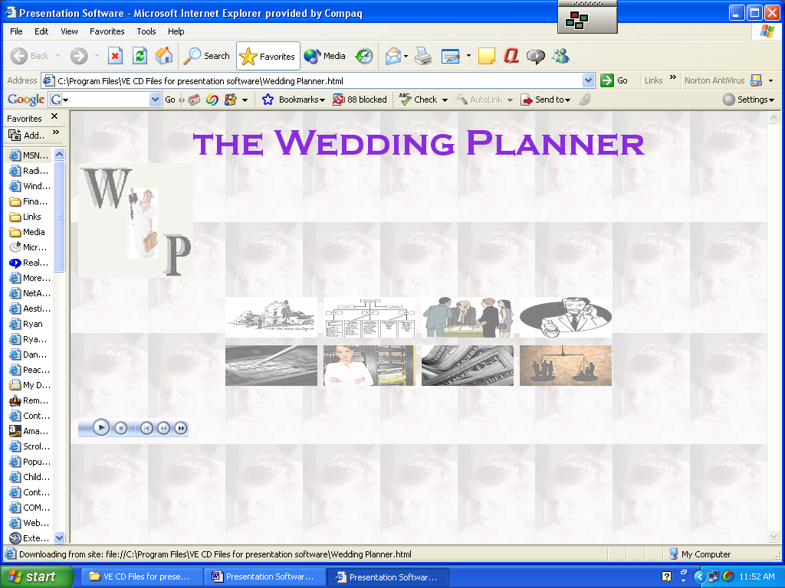

The main elements of the page are the: title, logo, a table containing eight
boxes, each containing a picture, and VCR type controls to play music. To see how these elements were created, simply go up to View on the menu bar of the browser and click source. The code will open in Notepad, a simple text-editor program that comes with all PC’s. It is located in the accessory group under all programs.
The page is coded in a language referred to as HTML or Hypertext Markup Language. It is a simple and easy to understand. After working with it you will wonder why you avoided it for so long. Many programs can convert the text you type in to HTML web-based documents: Microsoft Word, Excel, Power Point Dream weaver, Front Page and others have the option to save as an HTML document. Basically all they do is to put the HTML tags in for you. For example if you wanted to center a heading on a page using Word, You would use the alignment grid that sets up centering. If the user wants to create a web page out of this document, they merely save it as web page under the file save commands.

The Wedding Planner Home Page
The code for center in HTML <CENTER> Text typed </CENTER> tags are added to the document.
HTML tags usually come in pairs. One tells the browser to start the operation, the ending tag tells it to stop. Let’s look at the code in Notepad for the Wedding Planner presentation. The first tag, <HTML> tells the browser, Internet Explorer, Netscape Navigator, etc. to treat this as a web page. The </HTML> is the last tag on the page. Notice that there is one thing different. The opening tag does not have a ”/” after the “<”. That is how you tell an opening tag from and ending tag. If you scroll down through Notepad, you will see the ending tag.
The next tags <HEAD> </HEAD> is where you place the title for you web page.
<HEAD>
<TITLE>Presentation Software</TITLE>
</HEAD>
Titles are used by search engines to find your web page. They are also put on the top of the window telling the user the name of the page. Inside the <Head> tags others can also be placed for web searching. I chose not to put anything here, because the focus of our works to create presentation software.
The <BODY> </BODY> tags identify the boy or main part of the NTML document. Many tags can be used within the BODY tags: BACKROUND BGCOLOR to set the properties of the body. I wanted to use a small graphic, repeated many times as the back round. I used a small jpeg image of a bride. It is called wp3.jpg. It is quite small, only 101 pixels in width and 145 in height. You can use any picture you want. Just create a digital image of the picture and use a photo- editing program to adjust its size. I used such a program to adjust the size. I want the repeated image to stay in the back round and not be the focal point of the page. I used the same photo imaging program’s special effects to give the image the effect that you were viewing it through fog. Many other special effect options were also available. The line in our presentation software that creates this back round is
<BODY bgProperties=fixed background=wp3.jpg>
We want the image to repeated over and over. That is what is meant by a fixed back round. This is called a property of the back round. The name of the image appears next. Our image was called wp3.jpg
On the CD and on the web page are some other back rounds that you can experiment with: lambswool.jpg, Maize.jpg, Nature Bkgrd.jpg, Paper-linen.jpg, Paper-Pinkplaster.jpg. Create your own back rounds with a digital camera and photo-editing program.

You can also just use a back round color if you wish
<BODY BGCOLOR=”RRGGBB”>
Main page goes here
</BODY>
The RRGGBB refers to the red, green blue colors. For example the color beige is F5F5DC. You could create this back round color for your page by the following tag <BODY BGCOLOR=”F5F5DC”>. Another way of doing creating a beige back round would be to say <BODY BGCOLOR=”beige”> See Java Script color values at the end of this text for examples of colors that can be used.
The next line is Prints the name of our company, The Wedding Planner. It is centered using the <CENTER> , </CENTER> tag. The first <CENTER> begins the centering process. The </CENTER> tells the browser to stop centering text and pictures.
Font faces are many and varied. Type in the desired name after <FONT FACE=”. You can also specify the color and size of this font
<CENTER><FONT FACE = "Copperplate Gothic Bold" SIZE =7 COLOR="8A2BE2">the Wedding
Planner</CENTER>. You could have used Header Level tags to put in the title as well.
<CENTER><H2>The Wedding Planner</H2>.
The next line places the logo for the Wedding Planner on the page.
<IMG SRC="wedding planner logo.jpg" HEIGHT = 150 WIDTH = 150 BORDER=0><P>. You can specify the height and width of the log here as well. If you wanted to put a border around your logo, set the border for a number between 1 and 5. The <P> creates a new paragraph.
The next line creates a table. Tables are great ways of organizing data. You can put almost any other HTML tag into a table cell.
<TABLE BORDER=0 ALIGN=CENTER CELLPADDING=3 CELL SPACING=3>
The beginning <TABLE tag tells the browser that a table is coming. The </TABLE> lets the browser that you are finished working with tables. Tables can have borders. This one does not. Try a number between 1 and 5. If no border is set, the border is set by default to one pixel. CELLPADDING determines the amount of space between a cell’s borders and its contents. The default is one pixel. CELLSPACING determines the amount of space inserted between cells. The default is 2 pixels between cells.
When beginning a table, you need to tell the browser that you are starting a new table row. Rows are horizontal in arrangement. The command to do this is <TR>
Table cells are the individual entries that make up the row. The command to start a table cell are <TD>, which stands for table data. Below is an example of a table with two rows and three cells in each row.
<TABLE>
<TR>
<TD>Monday</TD><TD>Tuesday</TD><TD>Wednesday</TD>
</TR>
<TR>
<TD>Thursday</TD><TD>Friday</TD><TD>Saturday</TD>
</TR>
</TABLE>
The next line is a line that the browser ignores. You might ask, why we would want to use such a line. These lines are called comment lines. It gives the web developer a tool to make notes to themselves. Here we are just trying to say that the table data for the first cell is for the mission statement link.
<!- mission statement navigation icon-->. Another useful function for the comment line, it to comment out a line that you don’t want to show up, but still want to keep. To test web pages, you must always save the notepad first before refreshing the browser. You could use a comment to test out a number of different tags, and text without deleting them.
The next line creates a table cell with a link to another page called “mission.html”
<TD><A HREF="mission.html">
The next line puts an image of a mission into the table cell, which is centered and has no border. VSPACE specifies extra blank space or margins around the image
<IMG VSPACE=1 ALIGN="CENTER" BORDER="0" SRC="mission.gif"
This next line supplies an alternative string of text if the browser has no graphics capability. Almost all browser have this capability. But the line makes it so that when the user of the page, drags over the graphic, the text is displayed.
ALT="Mission Statement"></A></TD>.
The </A> ending tag is needed so that the link to the other page works and the </TD> is needed to state that this is the end of data for this table cell.

The rest of the page is just duplicating table cells to navigate to other pages. The format of the cell is identical.
<!- company information navigation icon-->
<TD><A HREF="company.html">
<IMG VSPACE=1 ALIGN="CENTER" BORDER="0" SRC="company.gif" ALT="Company Information"></A></TD>
<!- administration icon-->
<TD><A HREF="event.html">
<IMG VSPACE=1 ALIGN="CENTER" BORDER="0" SRC="admin.gif" ALT="Event Planning"></A></TD>

<!- sales and marketing-->
<TD><A HREF="sales.html">
<IMG VSPACE=1 ALIGN="CENTER" BORDER="0" SRC="sales.gif" ALT="Sales and Marketing"></A></TD>
</TR>
<TR>
<!- accounting-->
<TD><A HREF="accounting.html">
<IMG VSPACE=1 ALIGN="CENTER" BORDER="0" SRC="accounting.gif" ALT="Accounting"></A></TD>

<!- IT-->
<TD><A HREF="it.html">
<IMG VSPACE=1 ALIGN="CENTER" BORDER="0" SRC="it.gif" ALT="Web Page"></A></TD>

<!- Fundraising-->
<TD><A HREF="fundraising.html">
<IMG VSPACE=1 ALIGN="CENTER" BORDER="0" SRC="fundraising.gif" ALT="Fundraising"></A></TD>

<!-Human Resources-->
<TD><A HREF="hr.html">
<IMG VSPACE=1 ALIGN="CENTER" BORDER="0" SRC="hr.gif" ALT="Human Resources"></A></TD>
</TR>

The last tags tell the browser to end the table, end the body and end HTML. All are necessary for the page to work properly.
</TABLE>
</BODY>
</HTML>

Music can be played using HTML code. I choose a very old song by the Dixie Cups called Chapel of Love. Music can be played in a number of ways. I found this information at http://www.anablla.net/music.html.
<embed src="Chapel Of Love - Original.wma" width=144 height =25 autostart=false controls="smallconsole">
<noembed>
These lines load the music file and set the size of the controls. Autostart is set to false so that the music does not play as soon as the page is loaded. The controls allow the user to play, pause, rewind and fast-forward the song.

The Mission Statement Page
Double Click on Mission.html to see the next page of the presentation.
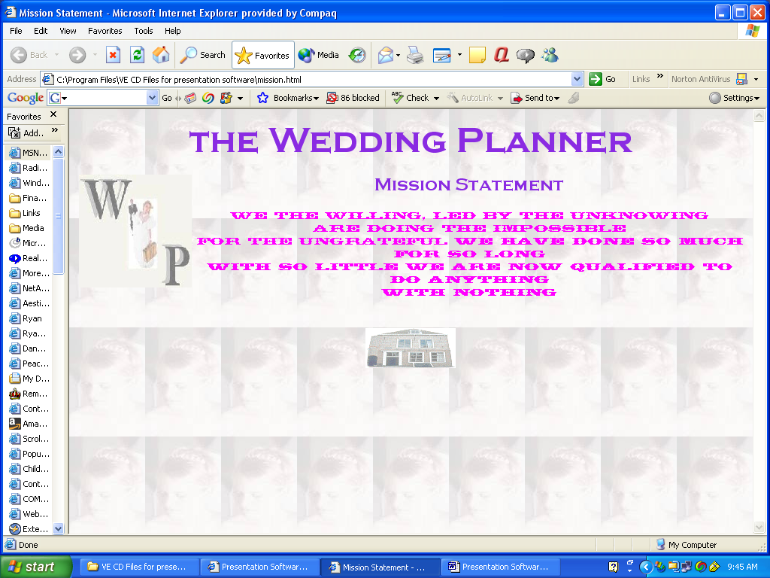

The page has four elements: Title, Logo, mission statement, navigational icon to return to Wedding planner home page. You will notice a few similarities with the home page. The back round and logo are the same. Click on VIEW the click on SOURCE to see the coding of this page of the presentation.
<HTML>
<HEAD>
<TITLE>Mission Statement</TITLE>
</HEAD>
<BODY bgProperties=fixed background=wp3.jpg>
<CENTER><FONT FACE = "Copperplate Gothic Bold" SIZE =7

COLOR="8A2BE2">the Wedding
Planner
<P>
<IMG SRC="wedding planner logo.jpg" ALIGN=LEFT HEIGHT = 150 WIDTH = 150

BORDER=0><P>
The back round is done in the same way. The logo is created in the same way as well. The same font name, color, and size were used as in the previous page. The title is different.
The next line sets the font face, color and size for the title Mission Statement
<CENTER><FONT FACE = "Copperplate Gothic Bold" SIZE =5 COLOR="8A2BE2">
The <B> tells the browser to put the following text in bold.
<B>Mission Statement</B>
The next lines are the actual mission statement. We begin with a new paragraph <P>, set the font face, size and color for the text of the mission statement, type the lines of the statement separated by <BR> breaks.
<P>
<FONT FACE="Thunderbird BT" size =2 color ="FF00FF">
We the willing, led by the unknowing
<Br>
Are doing the impossible
<Br>
For the ungrateful
<B>
We have done so much for so long
<Br>
With so little
<B>
We are now qualified to do anything
<Br>
With nothing
Now we tell the browser to stop centering and put in two breaks.
</CENTER>
<BR>
<BR>
Now we begin a table with no border centered with cellpadding and spacing. The first and only table row <TR> is next. We have a comment line telling us this table data is to be a link the Wedding Planner Home page. The link is a picture called home.gif. The ALT text displays when we pass the cursor over the picture. This link is structured the same as the ones on the home page.
<TABLE BORDER=0 ALIGN=CENTER CELLPADDING=3 CELL SPACING=3>
<TR>
<!- wedding planner home page-->
<TD><A HREF="Wedding Planner.html">
<IMG VSPACE=1 ALIGN="CENTER" BORDER="0" SRC="home.gif" ALT="Wedding

Planner Home Page"></A></TD>
</TR>

The ending tags are as follows.
</TABLE>
</BODY>
</HTML>

The Company Page

After clicking the Organization chart the Company page opens
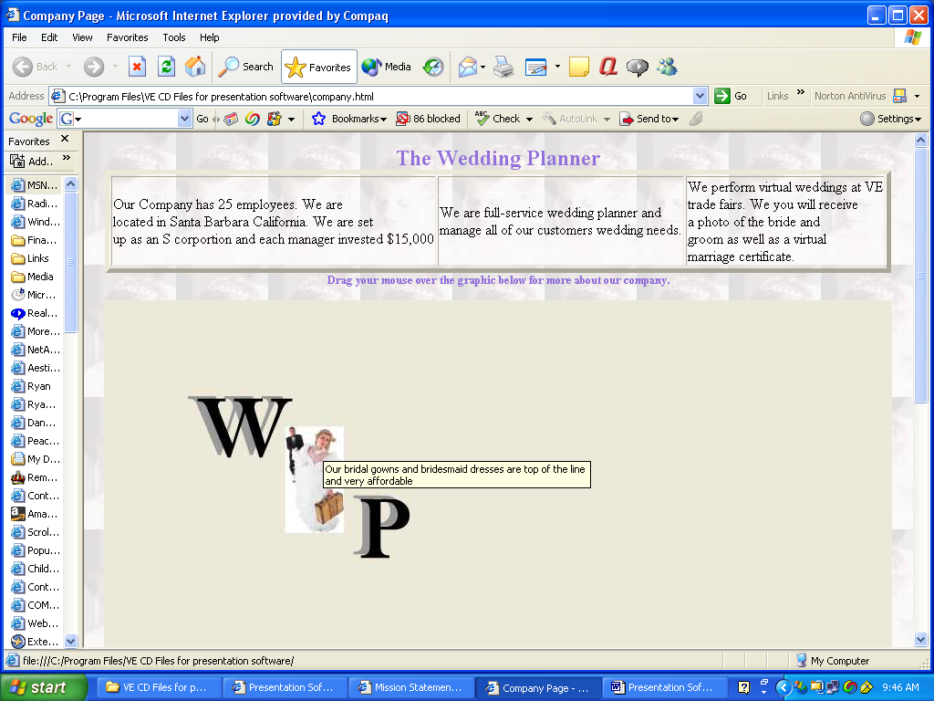
The usual opening tags are there for <HTML> , <HEAD> and <TITLE>. A program called Coffee Cup Image Maker was used to create a clickable image map out of the graphic. We cover clickable image maps in a few minutes. The name of the program used to generate this HTML document is listed inside the <HEAD> Tags.
You have seen this line before. It creates the background for the page. <Body bgProperties=fixed background=wp3.jpg>
The next line sets the font, color and size.
FONT FACE="comic sans" SIZE=5 COLOR="9370DB" >
<P> Creates a new paragraph.
<Center><H2>The Wedding Planner</H2></Center> Center the name of the company in header format.
Our next line is a comment line <!-- Created by Coffee Cup Image Mapper (www.coffeecup.com) -->
</Font> is an ending font tag.
Now we are going to create a table with three columns. In each of three cells is information about our company.
<Table border =5>
<TR>
<TD>Our Company has 25 employees. We are<BR> located in Santa Barbara California.

We are set<BR> up as an S corporation and each manager invested $15,000</TD>
<TD>We are a full-service wedding planner and<BR> manage all of our customers wedding

needs.</Td>
<TD>We perform virtual weddings at VE<BR> trade fairs. We you will receive <BR>a

photo of the bride and<BR> groom as well as a virtual<BR> marriage certificate.</Td>
</TR>
</Table>
<FONT FACE="comic sans" SIZE=2 COLOR="9370DB" > sets up the font name , size and color the text that follows.

Now we are going to put in the graphic that will become our clickable image map. We are going to treat a graphic as a collection of selectable regions, each of which points to a different link. You have probably seen this in web pages. Well this is how it works.

<!-- Beginning of Client Side Image Map -->
<img src="wp logo.jpg" USEMAP="#NotNamed" BORDER=0>
<map name="NotNamed"> The coffee cup software puts this in for you. You merely load the graphic into the program, define each clickable area by dragging a circle, rectangle, of polygon around the area that is to be active and tell the software which URL to go to when clicked. I just used a URL link to the Wedding Planner Home page. As you can see the ones at the top of the graphic are left blank. I did type the ALT information for all of the defined areas,
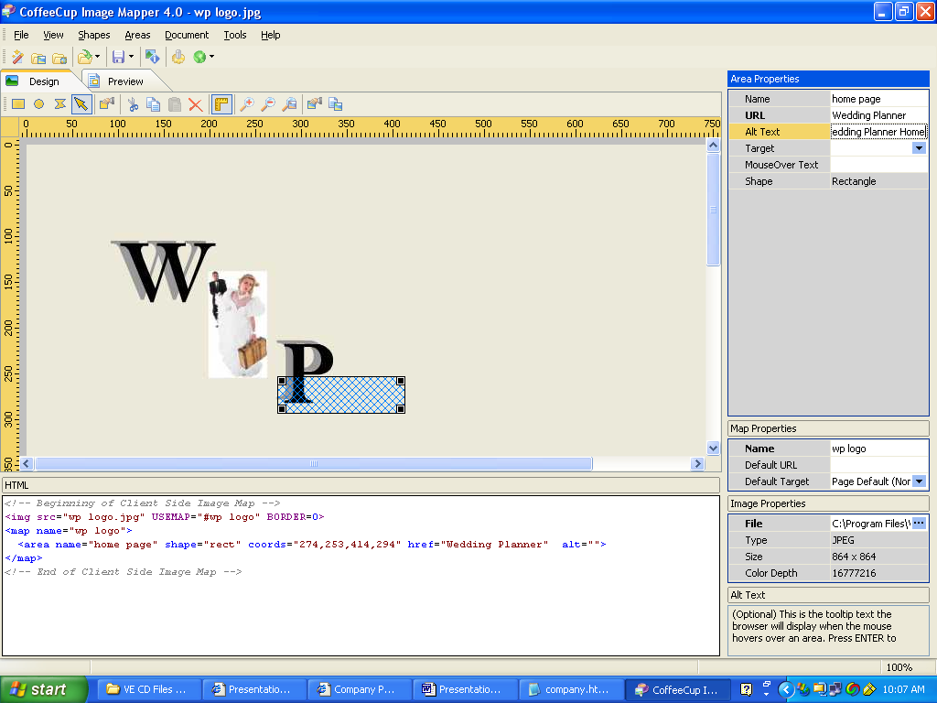

All of the following information is put in for you when outline the clickable areas.
<area name="full" shape="rect" coords="88,95,241,115" href="" alt="We are a full service

Wedding Service.">
<area name="Mens" shape="rect" coords="90,117,262,142" href="" alt="We offer

Tuxedos for the groom and best man as well as the attendants.">
<area name="bride" shape="rect" coords="218,149,258,245" href="" alt="Our bridal

Gowns and bridesmaid dresses are top of the line and very affordable">
<area name="cateringflowerspictures" shape="rect" coords="108,144,190,192" href=""

alt="Our packages include catering, flowers and photographs.">
<area name="djlimo" shape="rect" coords="269,212,373,229" href="" alt="We provide

Transportation for the wedding party in one of our elegant limousines. We can also provide a

Disc jockey to run your entire event.">
<area name="home" shape="rect" coords="276,234,365,286" href="Wedding

Planner.html" alt="Home Page">
</map>
<!-- End of Client Side Image Map -->
When you are finished defining areas and the corresponding URL and ALTs, you save the file. If you look down at the bottom of the Coffee Cup Image maker, you can add the HTML code that it puts in for you. Next, simply save the file. You can then open it in Notepad and add additional stuff. Be careful not to change the position of the graphic in any way as then the coordinates will not be the same and the clickable map will not work
I found the software easy to use and it was only $29.00. The software determines the coordinates of the map for you. There are a number of special deals for educators. Go to http://www.coffeecup.com/k12/
You can also get a 30-day trial version for free. That is what I did initially so I could try it out.
The last two tags end the body, </BODY> and the document </HTML>

Event Planner
The Event Planner, Web Page, Fundraising and Human Resources pages are set up in the same way. I will describe how to do one of these pages instead of all of them. The only thing that needs to be changed is the text in the table cells, the title and the name of the department. Here is what the Event Planner page looks like.
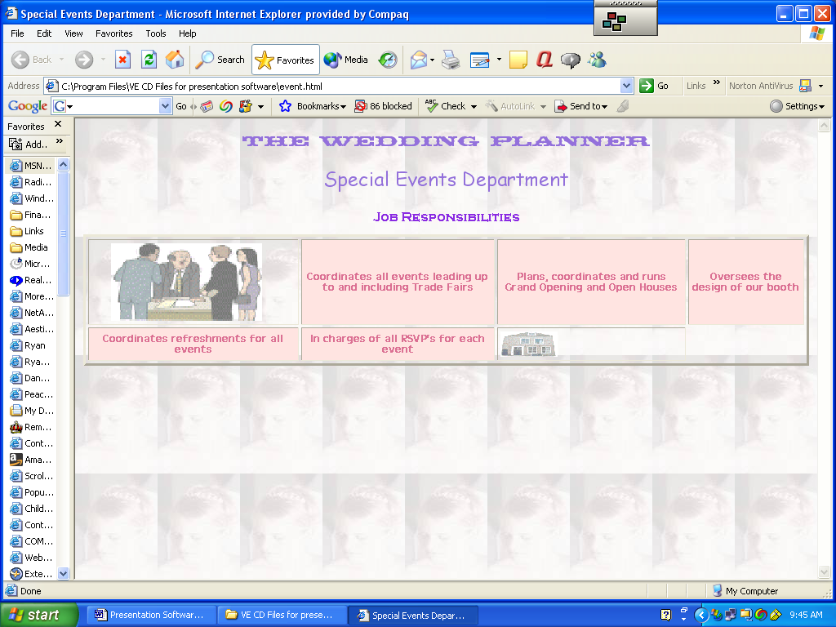
To see the code, click on View, the select Source.
<HTML><HEAD><TITLE>Special Events Department</TITLE>. This line let’s the browser know that this is a web based document, <HTML>. Remember that at the end of the document you need to have an ending <HTML> tag. The <HEAD> tags give us a place to put the title of the document.
<BODY bgProperties=fixed background="wp3.jpg">. This line creates the back round of the page. The picture used is called wp3.jpg. It was loaded into a photo- editing program and reduced in size. A special effects filter, was used to mute it.
<CENTER><FONT face="Thunderbird BT" color=#9370db size=4>The Wedding Planner. This line contains the name of our company. You can see the type of font size and color used. The title is centered using <CENTER>. Each line will continue to be centered until the ending </CENTER> tag is encountered.
<P></FONT><FONT face="Comic Sans MS" color=#9370db size=5>Special Events Department</FONT>
<P>
<P>
These next lines create a new paragraph, <P>, set up a new font, Comic Sans MS. The color is medium purple, size 5 and the put in the text, the name of the department. Two additional blank spaces, <P> are then added.
<TABLE cellSpacing=3 cellPadding=3 border=3>. This line creates a table, with 3 pixels of space between a cell’s borders and it contents. There is a 3-pixel border around the table and 3 pixels of space between individual cells.
<CAPTION><FONT face="Copperplate Gothic Bold" color=#8a2be2 size=3>Job Responsibilities</FONT></CAPTION></FONT>. The previous two lines create a caption for our table, Job Responsibilities. A particular font face is used along with a size of 3 and color blue violet.
To start the table, we need to tell the browser that this is a new row with the, <TR> command.
The next three lines tell the browser that in this first table cell we want an image with a height of 95 and a width of 185. The picture name is “admin.gif”. When you pass the cursor over the picture, the text in the ALT= command will display on the screen. The HSPACE and VSPACE tags, specify the extra blank space around the image.
<TD><IMG height=185.
alt="This Department coordinates all special company events. "
hspace=24 src="admin.gif" width=185 vspace=1 border=0></A></TD>
The next five sets of lines are designed to create the individual cells of the table. In each of the cells, some of the job responsibilities for the department are listed. After the fourth cell, <TD>, it is time to end this row, </TR> and to start another row of the table with the <TR>.
The last table data cell is designed to be a link back to the Wedding Planner’s main page.
<TD><A href="Wedding Planner.html"><IMG
alt="Home Page" src="home.gif" width=70 align=center vspace=1
border=0></A></TD></TR></CENTER></TABLE>
<P>
A picture, home.gif is used as the navigational link to the page. At the end of the table are the </TR>, to end the row; the ending centering tag, </CENTER>, the end table tag, </TABLE> and the document ending tag of </HTML>.

The other department pages” web, fundraising and human resources are very much the same as you can see by the layouts shown below.
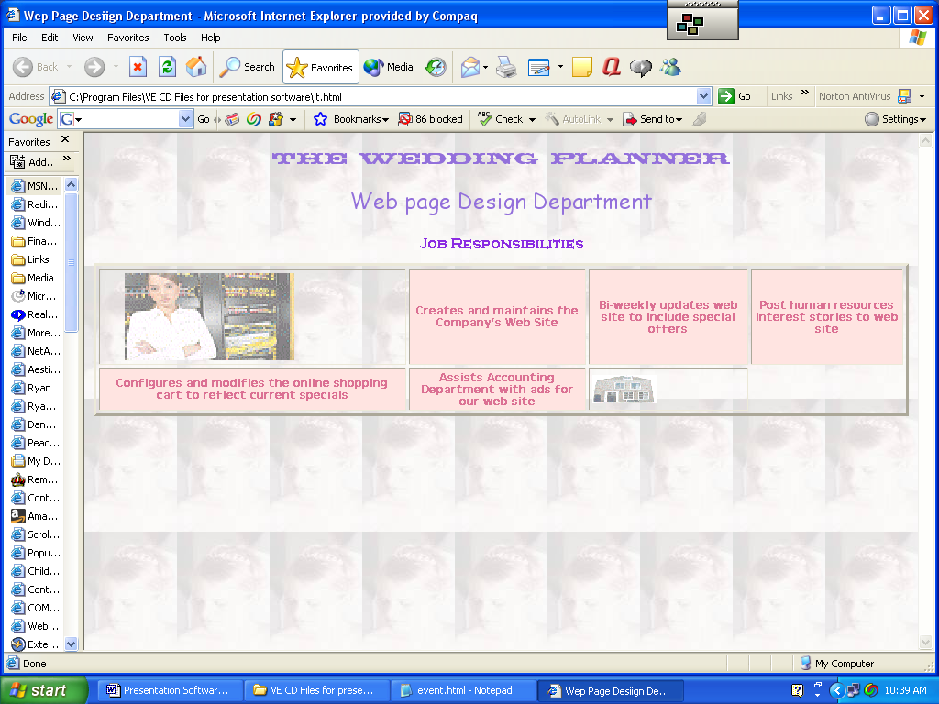
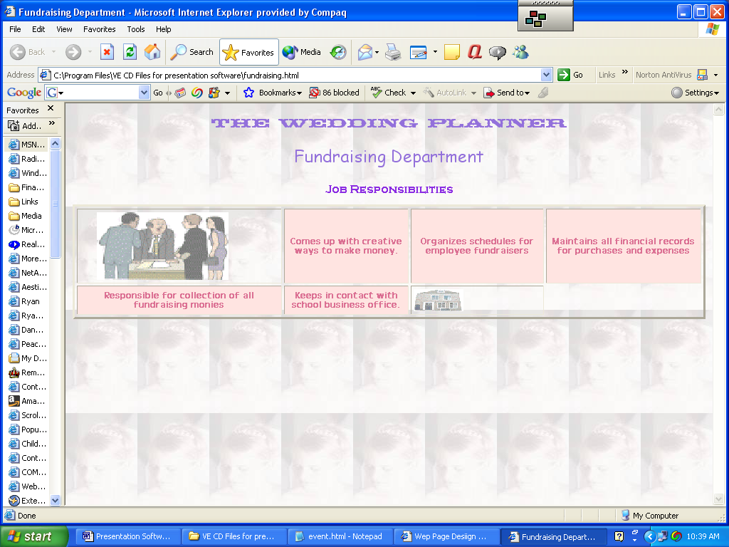
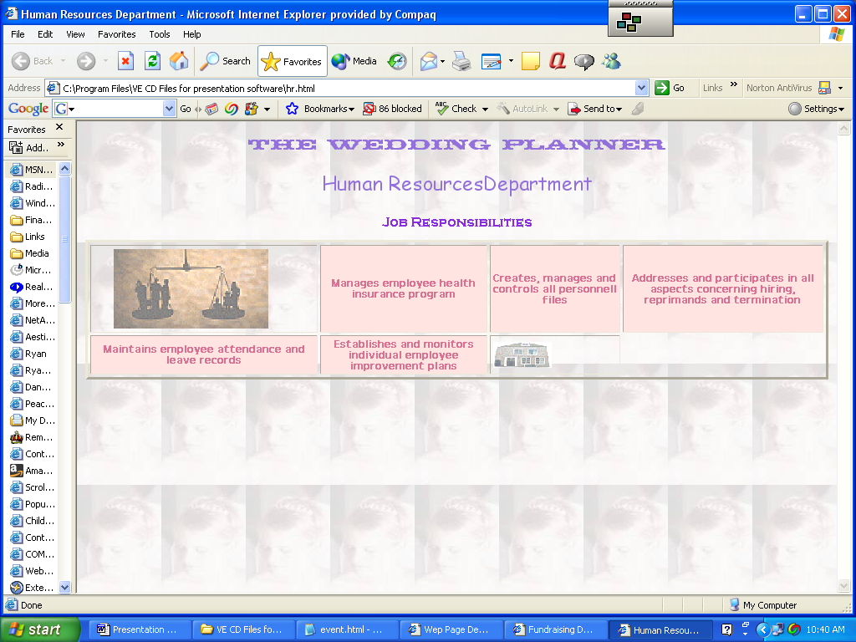
Sales and Marketing Department
If you want to have more detail in your presentation for each department, you might want to use the layout I used for the Sales and Marketing Department and the Accounting Department. Here is what the Sales and Marketing Department page looks like.
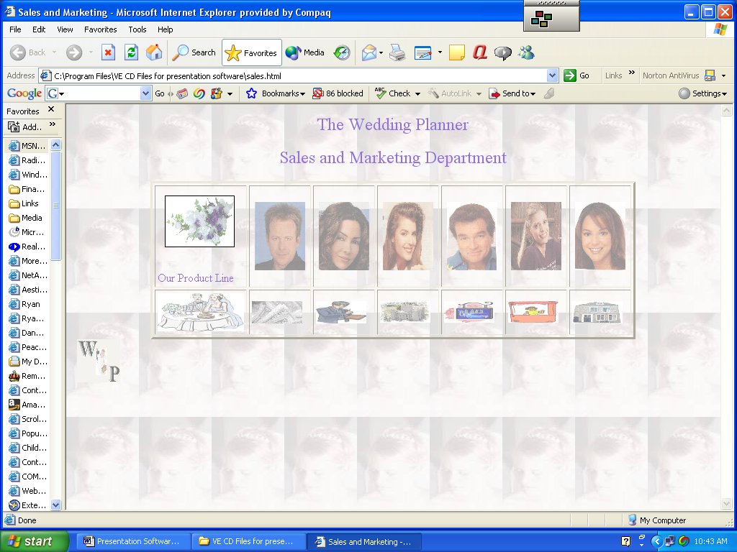
You will notice that the company name and department appear at the top of the page. A table with 7 columns and two rows contains revolving images showing our product line of bride’s dresses, tuxedos, limos, flowers, catering, etc. In the table cells that follow in the first row are pictures of all of our department’s members. When you drag over the picture, their job title appears. When you click on their pictures, a page will be loaded that shows that person and their individual job responsibilities. I just used some pictures that I scanned out of magazines. You would want to use digital photo of your actual employees.
The next four cells in the table, represented by picture are the Four P’s of marketing: product, price, promotion and place. Dragging over these cells, names each element in the marketing mix. Clicking on them will take you to another page describing in more detail that particular item. The last three cells are set aside for grand opening, trade fairs and returning to the Wedding Planner main page.
Let’s look at the construction of this page of the presentation. Click on View. Click on Source to see the HTML code. The first line sets up the title, as you have seen before in other pages. The <SCRIPT> tag let’s the browser that some JavaScript code is coming next. JavaScript tags always go inside the <HEAD>, </HEAD> tags. The next set of lines is designed to display a number of images in a revolving sort of way. Images were selected to depict the different items in out product line: tuxedos, dresses, cakes, reception, etc. The line
imgArray = new Array(7);
lets the browser that there are seven pictures in the group. Programmers call this an “array”. The first image in the array is [0] and the last is [6]
imgArray[0] = new Image;
imgArray[0].src = "cake.jpg";
The two lines above, load the image into the computer. The first loads a blank image, the second loads a picture of a cake.
The line that loads it in is document.banner.src = imgArray[index].src;
The program loops through all 7 images and loads them in one at a time. The program pauses, then loads the next blank picture and then the next real picture
After going through all the pictures, the index (0-6) is set to zero index = 0;
The program then goes back to the beginning and starts again.
The line that states: function select() is the part of the program that actually loads the pictures into browser’s memory. The brace {, begins the lines in the function called select. The line that states: index = Math.floor(Math.random()* 7); randomly loads all 7 images at random. The next line document.banner.src = imgArray[index].src; is the line that actually loads in the images. The next line
setTimeout("select()",1000);
is a delay, so that each picture stays on the screen for a short while. By changing the number you can adjust this delay. The line that states: return; starts the process all over again. The last brace } marks the end of the function.
</SCRIPT>
</HEAD>
These two lines tell the browser to end the JavaScript language. The next line tells the browser that this is the end of the head tag.
By now you should be familiar with the <BODY> tag. This one, however, has another element added in. <BODY onLoad = "select();" bgProperties=fixed background=wp3.jpg> OnLoad tells the browser that when the page is loaded into the browser, to call the Select function. Remember this is the one we just discussed, the JavaScript code. The rest of the code in this tag sets the background.
The next lines set up the name of the company and department.
<CENTER><FONT FACE="comic sans" SIZE=5 COLOR="9370DB" >The Wedding
Planner<P>
<FONT FACE="comic sans" SIZE=5 COLOR="9370DB" >Sales and Marketing Department
Now we are going to create a table for all the graphical links. Here is the line that does just that. <TABLE BORDER=3 CELLPADDING=3 CELLSPACING=3 >
Now it is time to display the revolving graphics. Note we display the picture of the cake first. Here is that line. <TD><img Src="cake.jpg" NAME = "banner" WIDTH=95 HEIGHT=70 BORDER=1 VSPACE=10 HSPACE=10>
This next line displays the text product line. We se the font, color and size. <FONT FACE="Comic Sans" SIZE =3 COLOR="9370DB">Our Product Line</TD>
The table data in the first row displays and creates a link tot another page for each employee in the department. The lines are almost identical except the for the link , the image, and the Alternative text (ALT).
<TD><A HREF="vpsales.html">
<IMG VSPACE=1 HSPACE=4 BORDER="0" SRC="vpsales.jpg" HEIGHT=95 WIDTH=70 ALT="Vice President of Sales an Marketing "></A></TD>
Make sure when working with graphic images and links to other pages, that all these documents are in the same folder. Using an image editing program’s special effects softened these photos. You may choose not to use this type of filter. It depends what type of business you have and the kind of impression that you want to make. The next five table cell data lines are for the individual employees in the department. We will look at their individual pages a little later on in the lesson.
To begin a new row, end the current row with </TR> and then use the <TR> tag to begin a new row.
The lines that follow are very similar to the ones we have just discussed. Each table data cell contains an image, which has a link to another page. The ALT describes what each one is.
<!- product icon-->
<TD><A HREF="product.html">
<IMG VSPACE=1 ALIGN="CENTER" BORDER="0" SRC="product.gif" ALT="Product"></A></TD>
There three more cells like the one above. One for Price, One for Promotion and one for Place.
There two additional table data cells. One is for grand openings and the other for trade fairs. The last cell is a link back to the Wedding Planner’s Home page.
<!- home icon-->
<TD><A HREF="Wedding Planner.html">
<IMG VSPACE=1 ALIGN="CENTER" BORDER="0" WIDTH=70 SRC="home.gif" ALT="Home Page"></A></TD>.

To end the presentation page, we use the following lines.
</TR>
</CENTER>
</TABLE>
<IMG SRC="wedding planner logo.jpg" Height =60 width=60 HSPACE=5>
</BODY>
</HTML>
Remember end the table row </TR> stop centering </CENTER>, end the table, </TABLE>. Insert the logo, end the body </BODY> and end the document, </HTML>
Vice President of Sales
Now let’s look at the links from the Sales and Marketing page. If we click on the first picture, the VP of sales and marketing, here the presentation page that loads.
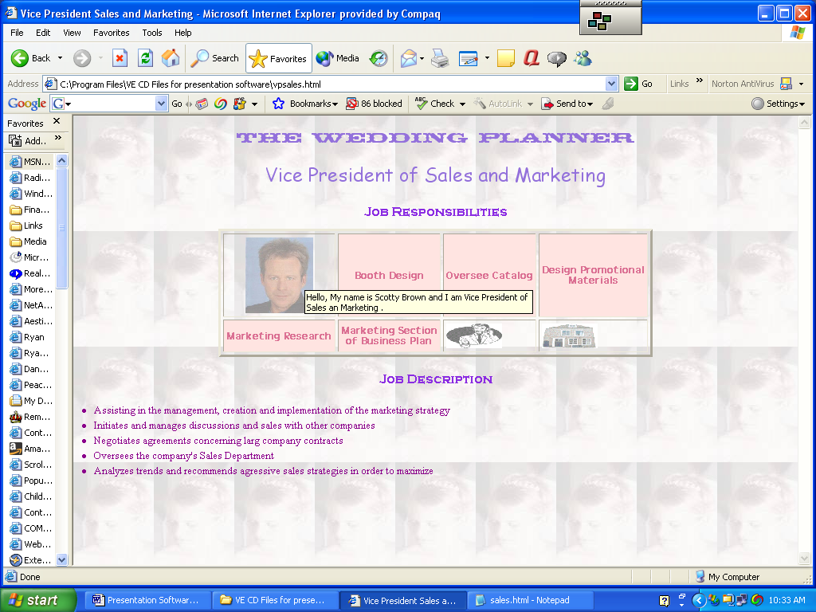
A you can see, the purpose of this page is to show the job responsibilities and job description of the Vice President of Sales. There also tow links on the page. One link takes you back to the Sales and Marketing page, the other to the main page.
Let’s view the source code of this page. Things should start to look pretty familiar to you by now if you have diligently gone thru the previous parts of this lesson.
One new thing is the listing of the job descriptions. The lines that do this are as follows
<LI>Assisting in the management, creation and implementation of the marketing strategy
<LI>Initiates and manages discussions and sales with other companies
<LI>Negotiates agreements concerning large company contracts
<LI>Oversees the company's Sales Department
<LI> Analyzes trends and recommends aggressive sales strategies in order to maximize.
The <LI> makes a list item and puts a circular outline in the shape of a bullet.
All of the department employee pages are designed in this way, so I won’t go into detail on each of them.
Click on the Sales and marketing link, to get back to the department’s presentation page. Now look don to the second row and see where it says “Product”. Click on that link to load that page. It should look like this.

Product
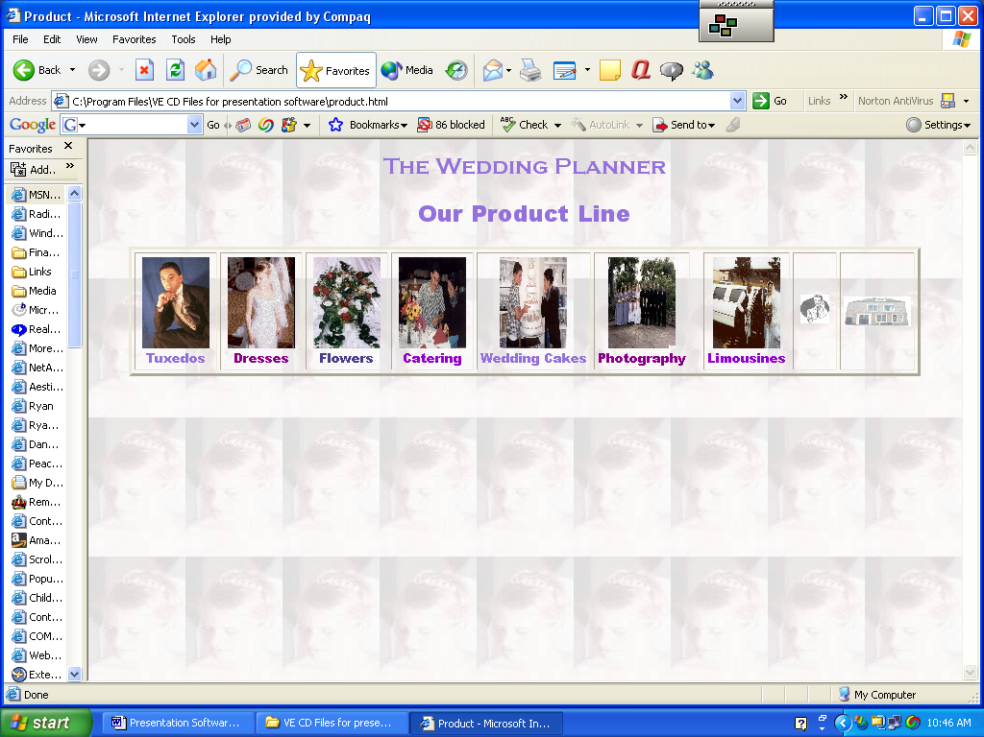
There seven items in out product line: tuxedos, dresses, flowers, catering, wedding cakes, photography and limousines. There is table data cell for each graphical link. There are also two other links: to the sales and marketing page and the main page.
Click on View, Source to see how this page is laid out. There is not much new here, with one exception. Since business partners were a major factor in the Wedding Planner, a link to each of their web site was put into the web page. I am using it here in the presentation software, since it really enhances a presentation. The line that makes this link is <A HREF="http://kingtux.com">. When giving you presentation, you will want to use your own business partners. First establish if they have a web page, then check it out. Finally create the link in your presentation software. Always make sure that you are connected to the Internet for these links to work. The links on this page are active web pages for these companies as of the time that this document was created, January 2007.
Click the sales and marketing link to back to the department’s page.

Click on the “Price” link to continue. Your page should look like the following
Price
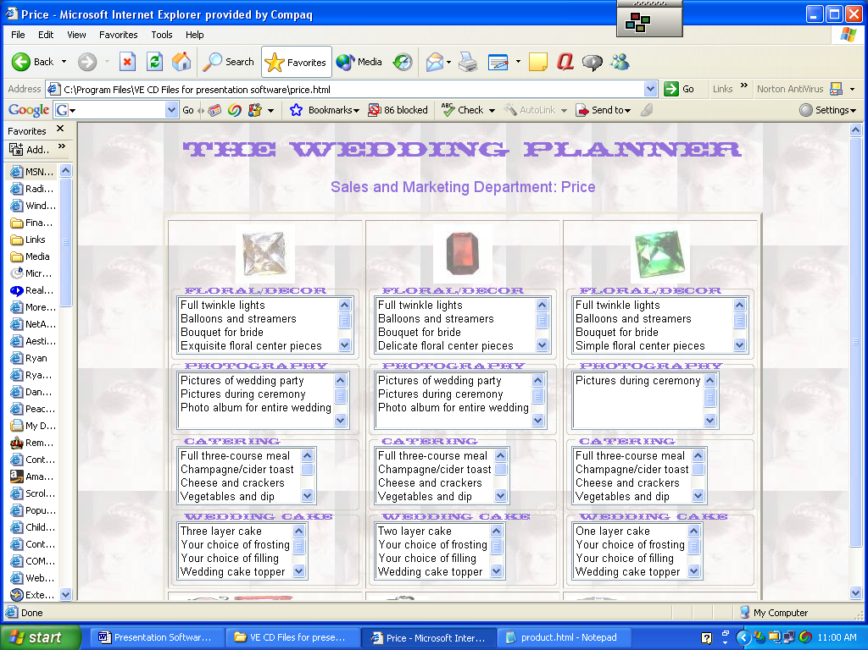
The page is set up to display the three packages: diamond, ruby and emerald. Features of each package are listed for each of the product lines: floral, photography, catering and wedding cake. The details are all arranged in a table, and each item appears in a list box, that can be scrolled up and down. Let’s look at the code for this page. Remember, click on View/Source. There are only three columns in the table one for each of the packages. Each package occupies a single table data cell, even though there are option boxes in the cell. The top part of the page should be very familiar by now.
<HTML>
<HEAD>
<TITLE>Price</TITLE>
</HEAD>

<BODY bgProperties=fixed background=wp3.jpg>
<BASEFONT = "Comic Sans MS" Size =5 Color= "9370DB">

<CENTER><FONT FACE="Thunderbird BT" SIZE=5 COLOR="9370DB" >The

Wedding
Planner<P>
<FONT FACE = Arial Black" Size =4 color ="9370DB">Sales and Marketing Department:

Price
The next part of this page creates a table for the three packages. Our first table row includes a picture of the different jewels and a general description of each package in the ALT part of the code. Remember the information here is shown, when the user passes the mouse over the gem.
<!- diamond package-->
<TD>
<CENTER>
<IMG VSPACE=1 ALIGN="CENTER" BORDER="0" WIDTH=70 SRC="diamond2.jpg" ALT="Diamond package $85.00 per person. Bridal gown, bridesmaid dresses, tuxedos and limousines are sold separately. "></A>
The next part of the code creates a list box with the different features of floral décor for the diamond package.
<FIELDSET> This tag lets you group sets of related fields together.

<LEGEND><FONT FACE = "Thunderbird BT" SIZE = 1 Color="9370DB">Floral/Decor</LEGEND>

<SELECT NAME="floral" SIZE="4" MULTIPLE> This line creates a list box named floral
selections are listed next to the options tags
<OPTION>Full twinkle lights
<OPTION>Balloons and streamers
<OPTION>Bouquet for bride
<OPTION>Exquisite floral centerpieces
<OPTION>Mirrors and candles
<OPTION>Setup reception and dance floor
</SELECT> This tag ends the list box
</FIELDSET> End of field

The rest of the code is just like the code explained above. The last few lines on this page are links to the sales and marketing page and the home page.
<!-Back to Sales and marketing page-->
<TD><A HREF="sales.html">
<IMG VSPACE=1 ALIGN="CENTER" BORDER="0" WIDTH=70 SRC="sales.gif" ALT="Back to Sales Page"></A></TD>

<!- home icon-->
<TD><A HREF="Wedding Planner.html">
<IMG VSPACE=1 ALIGN="CENTER" BORDER="0" WIDTH=70 SRC="home.gif" ALT="Home Page"></A></TD>
</TR>
</CENTER>
</TABLE>

Promotion
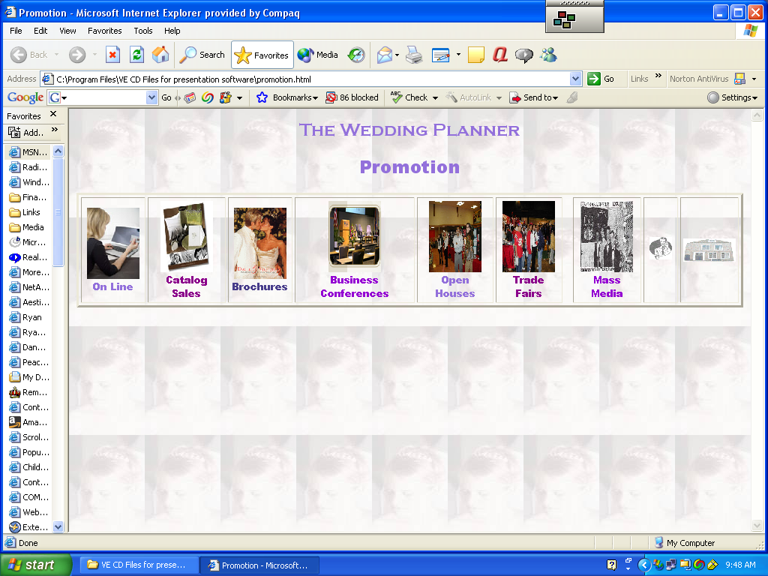
This page features graphics for on-line sales, catalog sales, business conferences, open houses, trade fairs and mass media. The last two table data cells contain navigational links back to the sales and marketing page and home page. The first link for on-line sales goes to the web page used by San Marcos High School for the Wedding Planner. Each cell has text explaining what each graphic is all about.
<CENTER><FONT FACE="Copperplate Gothic Bold" SIZE=5 COLOR="9370DB" Centers heading, sets font face, color and size.

>The Wedding Planner
<P>
<FONT FACE="Arial Black" SIZE=5 COLOR="9370DB" >Promotion
<P>
<P>
<TABLE BORDER=3 CELLPADDING=3 CELLSPACING=3 > Creates a table to hold graphic images
The rest of the next cells are basically the same
<TR>
<TD ALIGN = CENTER> <FONT FACE ="Arial Black" SIZE=2 COLOR="9370DB">
<A Href="http://wedding-planner.net"> The other cells except sales and marketing and home do not have links to another page. Just leave out the <A Href=”http:// line.:>
<IMG VSPACE=1 HSPACE=4 BORDER="0" SRC="online.jpg" HEIGHT=95

WIDTH=70 ALT="Our on-line sales are one of the main vehicles to promote our company,

since our customers are located all around the world."></A><BR>On Line</TD>

Place
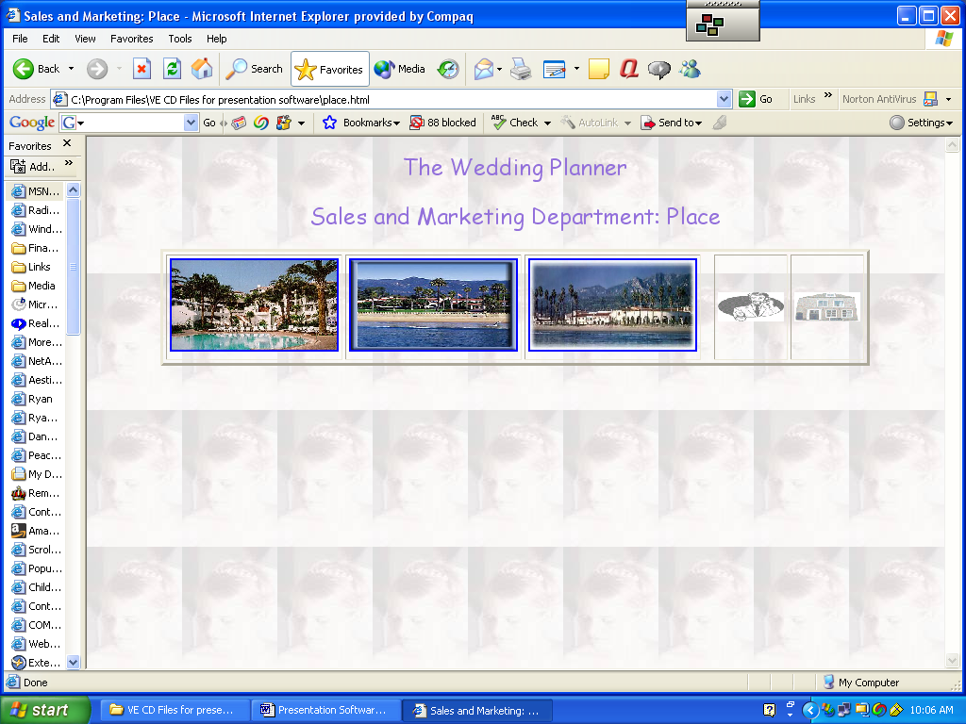
Our company sets up Weddings at three hotels in Santa Barbara: the Bacara, The Double Tree and the Biltmore. All are top-quality and very expensive hotels. Each has banquet facilities for wedding receptions. The software features two pictures of each resort. By passing the mouse over each picture it changes to another as you move the mouse away from the graphic. The first part of this process is a java-Script function to load the images into an array. You studied this earlier in the lesson when you looked at the sales and marketing page for our product.
<HTML>
<TITLE>Sales and Marketing: Place</TITLE>
<HEAD>
<SCRIPT>
bacara = new Image;
bacara.src = "bacara.jpg";
bacara2 = new Image;
bacara2.src= "bacara2.jpg";

biltmore=new Image;
biltmore.src="biltmore.jpg";
biltmore2=new Image
biltmore2.src="biltmore2.jpg";

fessparker=new Image;
fessparker.src="fess parker.jpg";
fessparker2=new Image;
fessparker2.src="fess parker2.jpg";
</SCRIPT>
</HEAD>
Make sure that your images of the resort are in the same folder as the HTML page.
The following lines set up the heading of the page.
<BODY bgProperties=fixed background=wp3.jpg>

<CENTER><FONT FACE="Comic Sans MS" SIZE=5 COLOR="9370DB" >The Wedding
Planner<P>
Sales and Marketing Department: Place
<P>
<P>
A table is created to hold all the pictures using the following
<TABLE BORDER=3 CELLPADDING=3 CELLSPACING=3 >
<TR>
The first table data cell creates a link to the actual resort’s home page, so you’re your audience can see more actual pictures and details about the resort. The onMouseOver and MouseOut functions show the two different pictures of the resort, based on where the mouse is located.
<TD>

<A HREF = "HTTP://www.bacararesort.com"
onMouseOver="document.picture.src=bacara.src;"
onMouseOut= "document.picture.src = bacara2.src;">
<IMG SRC="bacara.jpg"
NAME="picture"
WIDTH =175
HEIGHT= 95
ALT="The Bacara Hotel and Resort is a five star hotel located in beautiful Santa Barbara California. Your reception can be held in one of the ball rooms, on the patio facing the beach or one of the restaurants."
</A>

The rest of the cells of the table are very similar, except for different links, pictures and descriptions of the resorts.
The last two cells are navigational ones to return to the sales and marketing page or the home page
Grand Openings
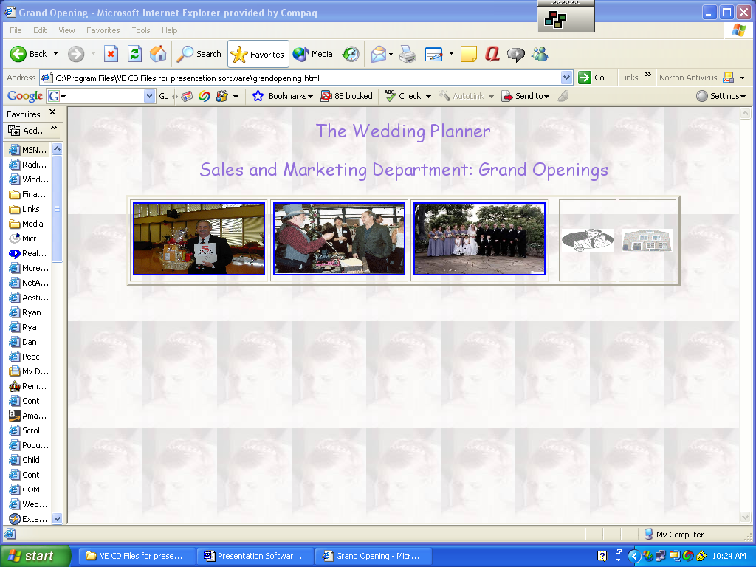
This page works just like the last one. There are no links, however, except back to sales and marketing and the home page
Trade Fairs
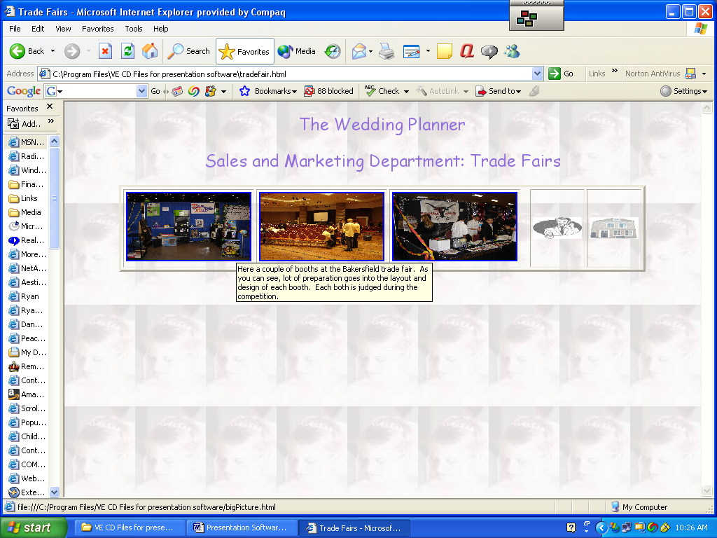
This page is set up just like the previous one. Its purpose is to show the audience what trade fairs are all about using six pictures and descriptions.

Accounting Department

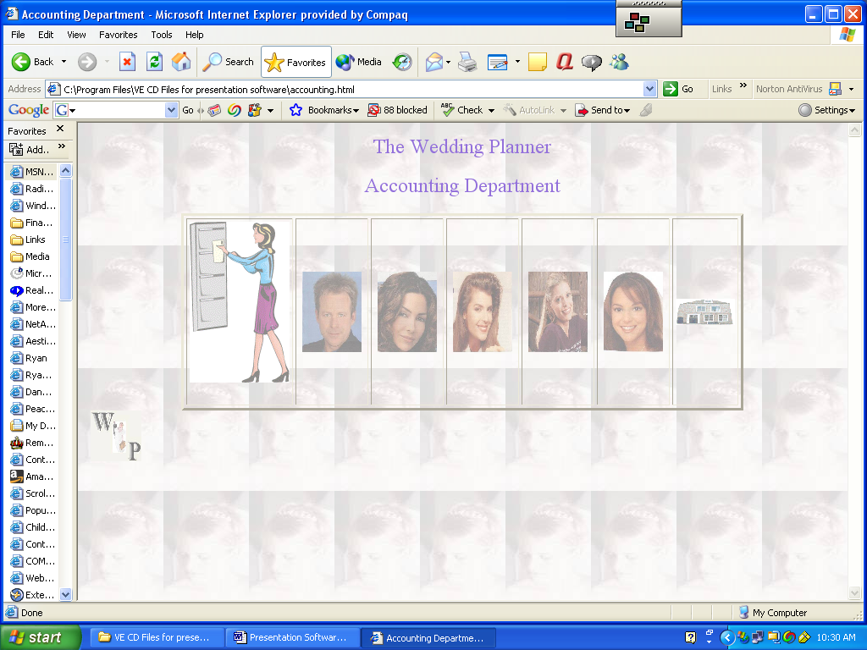
This page features seven table data cells. Each one has separate links to other pages. The pictures of the employees are the same ones I used for the sales and marketing department. You, of course, would want to use actual pictures of your department people. Make sure that your images are in the same folder as the HTML page and the code to load the images is the same as the file name you used to save your pictures. I used jpeg as the picture format and a fog filter to soften each picture. Each picture takes you to another page that describes each employee’s job description and duties. These employee pages are identical in format to what I used for the employees of the sales and marketing department.
The first table cell is different for the others. I used image-mapping software to create links for the financial statements our company produces each month: Trial Balance, Income Statement and Balance Sheet. Each of the bottom three-file drawers in the graphic represents a link to each of these documents. The heading is similar to all other presentation page headings.
The code for the file cabinet is listed below. Remember I used click able image mapping software to create this. See previous sections on a full explanation of how this software works.
<TD><!-- Beginning of Client Side Image Map -->
<img src="cabinet2.gif" USEMAP="#NotNamed" BORDER=0 >
<map name="NotNamed">
<area shape="rect" coords="6,31,44,57" href="trialbalance.html" alt="Trial Balance">
<area shape="rect" coords="2,63,45,90" href="incomestatement.html" alt="Income Statement">
<area shape="rect" coords="3,93,44,126" href="balancesheet.html" alt="Balance Sheet">
</map>
<!-- End of Client Side Image Map -->
Trial Balance
By clicking on the second drawer of the file cabinet, the browser loads a trial balance for The Wedding Planner. This is after the first month of operation. The data was created by the General Ledger and Financial reports that I wrote.
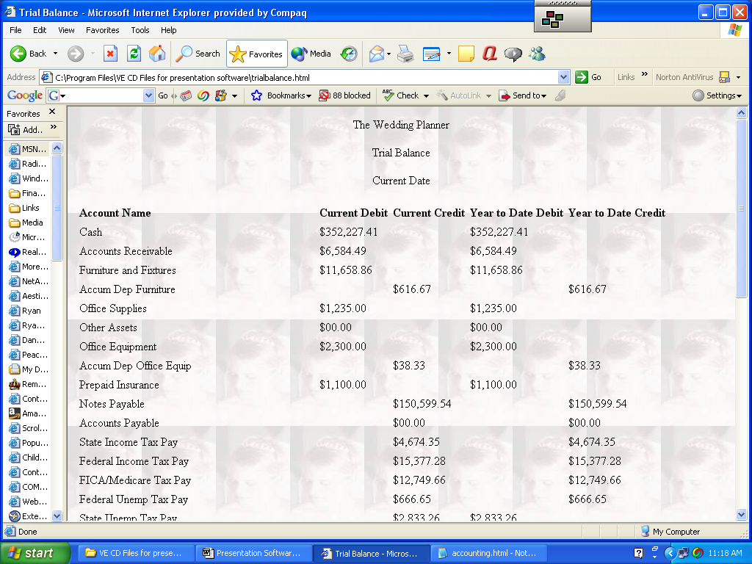
After making the heading a table is set up with seven columns. The first column is wider to accommodate longer account names. The other six, the ones that contain the numbers are identical in length. A table was used to line up the data. Totals for each column appear at the end of each column. Year-to-date as well as current monthly number is incorporated into the software. You may choose to use a spreadsheet to set up your financial statements if you wish.
The HTML tags to create the first row of the table, the headings, are shown below. Not the COLSPAN=2 tag to create a wider column.
<TR>
<TD> <B>Account Name</TD>
<TD COLSPAN=2></TD>
<TD><B>Current Debit</B></TD>
<TD><B>Current Credit</B></TD>
<TD><B>Year to Date Debit</B></TD>
<TD><B>Year to Date Credit</B></TD>
</TR>
Each new row contains the information about one account. The cash account is shown below. All the rest of the lines are very similar until you get to the totals.
<TR>
<TD>Cash</TD>
<TD COLSPAN=2></TD>
<TD>$352,227.41</TD>
<TD></TD>
<TD>$352,227.41</TD>
<TD></TD>
</TR>
These lines make the totals
<TR>
<TD>Totals</TD>
<TD COLSPAN=2></TD>
<TD><U><B>$701,609.63</B></U></TD>
<TD><U><B>$701,609.63</B></U></TD>
<TD><U><B>$701,609.63</B></U></TD>
<TD><U><B>$701,609.63</B></U></TD>
</TR>
<TR>
These lines provide the link to the accounting home page and the Wedding Planner home page.
<!- accounting-->
<TD><A HREF="accounting.html">
<IMG VSPACE=1 ALIGN="CENTER" BORDER="0" SRC="accounting.gif" ALT="Accounting Page"></A></TD>

<!- home icon-->
<TD><A HREF="Wedding Planner.html">
<IMG VSPACE=1 ALIGN="CENTER" BORDER="0" SRC="home.gif" ALT="Home Page"></A></TD>

</TR>

Income Statement
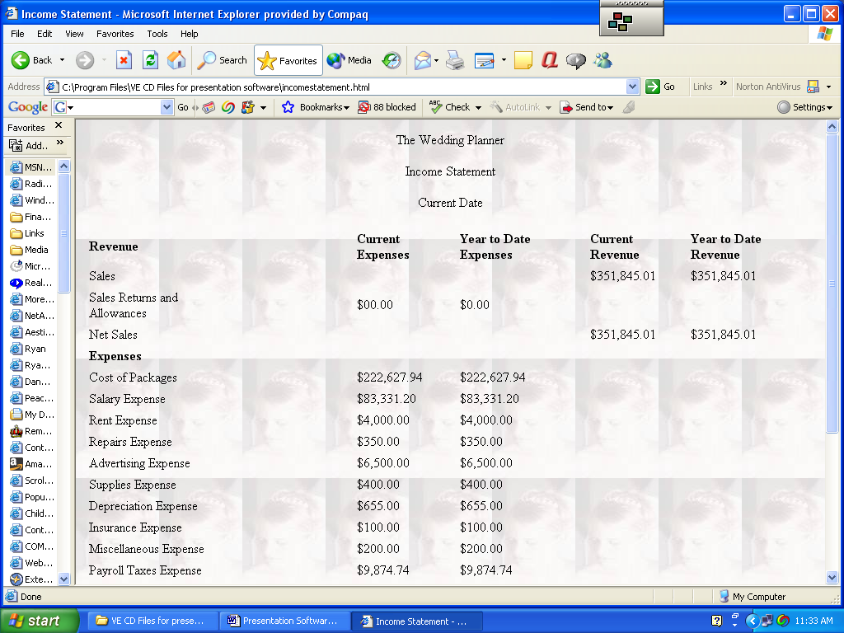
By clicking on the third drawer of the filing cabinet, you load the income statement page. This page is almost identical to the trail balance one, except it contains different columns and not all the accounts listed in the trial balance. Links to the accounting page and Wedding planner home page are provided at the end of the income statement.

Balance Sheet
By clicking on the bottom drawer of the filing cabinet you will produce the Balance Sheet for the Wedding Planner.
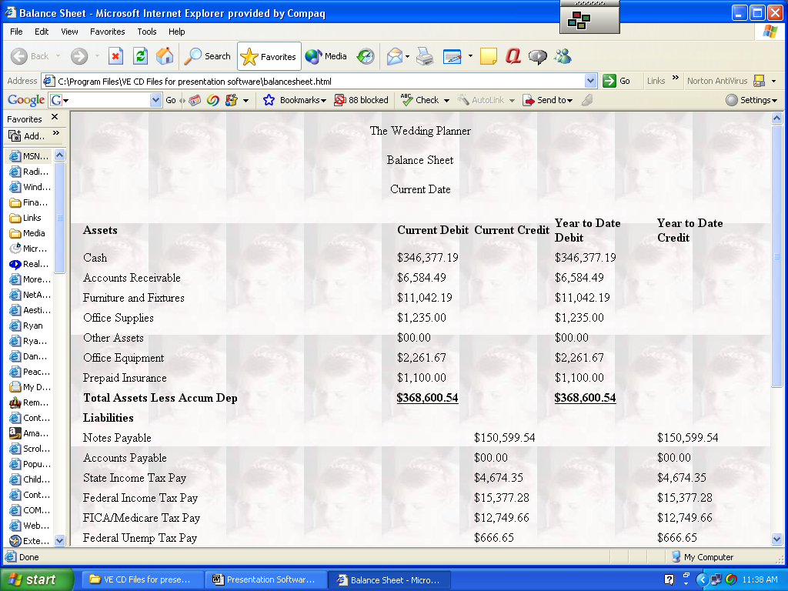
Same format as the other financial statement pages

Your Own Presentation Software
I hope that this lesson has been helpful for you. As you can see there are many ways to make a presentation in addition to using PowerPoint. Try out little pieces of code and tags. Make simple revisions to color, backgrounds, fonts and table arrangements. That is the way you will learn how to become proficient in HTML coding. Pick up a book on HTML or look at some of the tutorials available on the Web.
JavaScript Color Values

Color Red Green Blue Triplet
aliceblue F0 F8 FF F0F8FF
antiquewhite FA EB D7 FAEBD7
aqua 00 FF FF 00FFFF
aquamarine 7F FF D4 7FFFD4
azure F0 FF FF F0FFFF
beige F5 F5 DC F5F5DC
bisque FF E4 C4 FFE4C4
black 00 00 00 000000
blanchedalmond FF EB CD FFEBCD
blue 00 00 FF 0000FF
blueviolet 8A 2B E2 8A2BE2
brown A5 2A 2A A52A2A
burlywood DE B8 87 DEB887
cadetblue 5F 9E A0 5F92A0
chartreuse 7F FF 00 7FFF00
chocolate D2 69 1E D2691E
coral FF 7F 50 FF7F50
cornflowerblue 64 95 ED 6495ED
cornsilk FF F8 DC FFF8DC
crimson DC 14 3C DC143C
cyan 00 FF FF 00FFFF
darkblue 00 00 8B 00008B
darkcyan 00 8B 8B 008B00
darkgoldenrod B8 86 0B B8860B
darkgray A9 A9 A9 A9A9A9
darkgreen 00 64 00 006400
darkkhaki BD B7 6B BDB76B
darkmagenta 8B 00 8B 8B008B
darkolive 55 6B 2F 556B2F
darkorange FF 8C 00 FF8C00
darkorchid 99 32 CC 9932CC
darkred 8B 00 00 8B0000
darksalmon E9 96 7A E9967A
darkseagreen 8F BC 8F 8FBC8F
darkslateblue 48 3D 8B 483D8B
darkslategray 2F 4F 4F 2F4F4F
darkturquoise 00 CE D1 00CED1
darkviolet 94 00 D3 9400D3
deeppink FF 14 93 FF1493
deepskyblue 00 BF FF 00BFFF
dimgray 69 69 69 696969
dodgerblue 1E 90 FF 1E90FF
firebrick B2 22 22 B22222
floralwhite FF FA F0 FFFAF0
forestgreen 22 8B 22 228B22
fuchsia FF 00 FF FF00FF
gainsboro DC DC DC DCDCDC
ghostwhite F8 F8 FF F8F8FF
gold FF D7 00 FFD700
goldenrod DA A5 20 DAA520
gray 80 80 80 808080
green 00 80 00 008000
greenyellow AD FF 2F ADFF2F
honeydew F0 FF F0 F0FFF0
hotpink FF 69 B4 FF69B4
indianred CD 5C 5C CD5C5C
indigo 4B 00 82 4B0082
ivory FF FF F0 FFFFF0
khaki F0 E6 8C F0E68C
lavender E6 E6 FA E6E6FA
lavenderblush FF F0 F5 FFF0F5
lawngreen 7C FC 00 7CFC00
lemonchiffon FF FA CD FFFACD
lightblue AD D8 E6 ADD8E6
lightcoral F0 80 80 F08080
lightcyan E0 FF FF E0FFFF
lightgoldenrod FA FA D2 FAFAD2
lightgreen 90 EE 90 90EE90
lightgray D3 D3 D3 D3D3D3
lightpink FF B6 C1 FFB6C1
lightsalmon FF A0 7A FFA07A
lightseagreen 20 B2 AA 20B2AA
lightskyblue 87 CE FA 87CEFA
lightslategray 77 88 99 778899
lightsteelblue B0 C4 DE B0C4DE
lightyellow FF FF E0 FFFFE0
lime 00 FF 00 00FF00
limegreen 32 CD 32 32CD32
linen FA F0 E6 FAF0E6
magenta FF 00 FF FF00FF
maroon 80 00 00 800000
mediumaquamarine 66 CD AA 66CDAA
mediumblue 00 00 CD 0000CD
mediumorchid BA 55 D3 BA55D3
mediumpurple 93 70 DB 9370DB
mediumseagreen 3C B3 71 3CB371
mediumslateblue 7B 68 EE 7B68EE
mediumspringgreen 00 FA 9A 00FA9A
mediumturquoise 48 D1 CC 48D1CC
mediumvioletred C7 15 85 C71585
midnightblue 19 19 70 191970
mintcream F5 FF FA F5FFFA
mistyrose FF E4 E1 FFE4E1
moccasin FF E4 B5 FFE4B5
navajowhite FF DE AD FFDEAD
navy 00 00 80 000080
oldlace FD F5 E6 FDF5E6
olive 80 80 00 808000
olivedrab 6B 8E 23 6B8E23
orange FF A5 00 FFA500
orangered FF 45 00 FF4500
orchid DA 70 D6 DA70D6
palegoldenrod EE E8 AA EEE8AA
palegreen 98 FB 98 90FB98
paleturquoise AF EE EE AFEEEE
paleviolet DB 70 93 DB7093
papaywhip FF EF D5 FFEFD5
peachpuff FF DA B9 FFDAB9
peru CD 85 3F CD853F
pink FF C0 CB FFC0CB
plum DD A0 DD DDA0DD
powderblue B0 E0 E6 B0E0E6
purple 80 00 80 800080
red FF 00 00 FF0000
rosybrown BC 8F 8F BC8F8F
royalblue 41 69 E1 4169E1
saddlebrown 8B 45 13 8B4513
salmon FA 80 72 FA8072
sandybrown F4 A4 60 F4A460
seagreen 2E 8B 57 2E8B57
seashell FF F5 EE FFF5EE
sienna A0 52 2D A0522D
silver C0 C0 C0 C0C0C0
skyblue 87 CE EB 87CEEB
slateblue 6A 5A CD 6A5ACD
slategray 70 80 90 708090
snow FF FA FA FFFAFA
springgreen 00 FF 7F 00FF7F
steelblue 46 82 B4 4682B4
tan D2 B4 8C DWB48C
teal 00 80 80 008080
thistle D8 BF D8 D8BFD8
tomato FF 63 47 FF6347
turquoise 40 E0 D0 40E0D0
violet EE 82 EE EE82EE
wheat F5 DE B3 F5DEB3
white FF FF FF FFFFFF
whitesmoke F5 F5 F5 F5F5F5
yellow FF FF 00 FFFF00
yellowgreen 9A CD 32 9ACD32

